CHAPTER 8: CONCLUSION AND FUTURE SCOPE

CONCLUSION:
The proposed low-power and high-accuracy approximate multiplier with reconfigurable truncation has been successfully designed, implemented, and verified in System Verilog HDL. Functional verification was carried out using comprehensive testbenches that included both directed and random testcases to validate correctness across different truncation configurations. Simulation results confirm that the design achieves an optimal trade-off between power, area, delay, and accuracy. The verification environment achieved 100% code coverage (statement, branch, and toggle coverage), ensuring thorough validation of all functional paths. Reconfigurable truncation was tested under multiple scenarios to demonstrate adaptability for application-specific requirements. The synthesis and coverage reports confirm that the System Verilog-based design is efficient, accurate, scalable, and suitable for integration into low-power, error-tolerant digital systems.
FUTURE SCOPE:
Adaptive Approximation – Develop intelligent hardware that dynamically adjusts truncation level based on workload and error tolerance.
Integration in AI Accelerators – Extend design for tensor processing units (TPUs) and custom accelerators for efficient DNN computation.
Technology Scaling – Implement and optimize in advanced nodes (e.g., 7nm/5nm) for further power and area savings.
Error-Resilient Architectures – Combine with error-detection and correction mechanisms for safety-critical applications.
FPGA/ASIC Prototyping – Real-time implementation and benchmarking for performance validation.
Hybrid Designs – Explore combinations with other approximate computing techniques (voltage scaling, logic simplification).
Application-Specific Customization – Tailor the truncation logic for domain-specific processors (medical IoT, AR/VR, automotive).

CHAPTER 9: APPENDIX

SOURCE CODE
1. Program Block
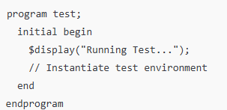
2. Environment (Env)
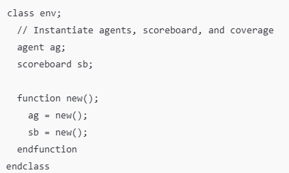
3. Bus Functional Model (BFM)
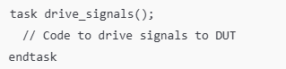
4. Generator (Gen)
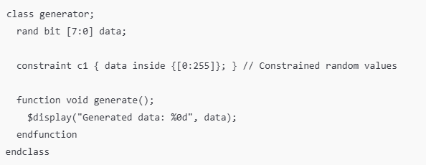
5. Transaction (Tx)
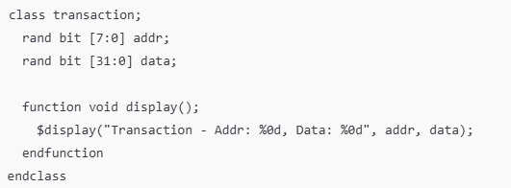
6. Coverage (Cov)
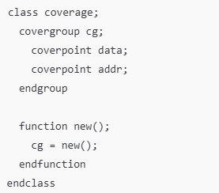
7. Monitor (Mon)
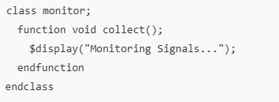
8. Interface
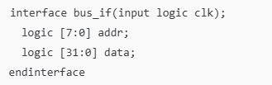

9. Scoreboard
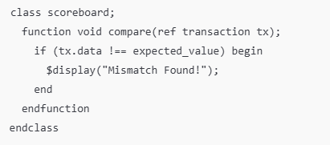

RECON_MUL_APPR:
module RECON_MUL_APPR(A,B,Tr,OUT);
input [7:0]A,B;
input [3:0]Tr;
output [15:0]OUT;
wire [9:0]t,c1;
wire [25:0]c;
wire [21:0]s;
wire [15:0]s1;
wire [2:0]err;
wire [5:0]p;
wire [18:1]g,r;
wire [7:0]carry;
wire [12:0]o;
wire [12:2]d;
PPD p1(Tr[0],A[0],B[0],t[0]);
PPD p2(Tr[0],A[0],B[1],t[1]);
PPD p3(Tr[0],A[0],B[2],t[2]);
PPD p4(Tr[0],A[0],B[3],t[3])
PPD p5(Tr[1],A[0],B[4],c[0]);
PPD p6(Tr[1],A[0],B[5],c[1]);
PPD p7(Tr[1],A[0],B[6],c[2]);
PPD p8(Tr[1],A[0],B[7],c[3]);
PPD p9(Tr[0],A[1],B[0],t[4]);
PPD p10(Tr[0],A[1],B[1],t[5]);
PPD p11(Tr[0],A[1],B[2],t[6]);
PPD p12(Tr[1],A[1],B[3],c[4]);
PPD p14(Tr[1],A[1],B[4],c[5]);
PPD p14(Tr[1],A[1],B[5],c[6]);
PPD p15(Tr[1],A[1],B[6],c[7]);
PPD p16(Tr[2],A[1],B[7],s[0]);
PPD p17(Tr[0],A[2],B[0],t[7]);
PPD p18(Tr[0],A[2],B[1],t[8]);
PPD p19(Tr[1],A[2],B[2],c[8]);
PPD p20(Tr[1],A[2],B[3],c[9]);
PPD p21(Tr[1],A[2],B[4],c[10]);
PPD p22(Tr[1],A[2],B[5],c[11]);
PPD p23(Tr[2],A[2],B[6],s[1]);
PPD p24(Tr[2],A[2],B[7],s[2]);
PPD p25(Tr[0],A[3],B[0],t[9]);
PPD p26(Tr[1],A[3],B[1],c[12]);
PPD p27(Tr[1],A[3],B[2],c[13]);
PPD p28(Tr[1],A[3],B[3],c[14]);
PPD p29(Tr[1],A[3],B[4],c[15]);
PPD p30(Tr[2],A[3],B[5],s[3]);
PPD p31(Tr[2],A[3],B[6],s[4]);
PPD p32(Tr[2],A[3],B[7],s[5]);
PPD p33(Tr[1],A[4],B[0],c[16]);
PPD p34(Tr[1],A[4],B[1],c[17]);
PPD p35(Tr[1],A[4],B[2],c[18]);
PPD p36(Tr[1],A[4],B[3],c[19]);
PPD p37(Tr[2],A[4],B[4],s[6]);
PPD p38(Tr[2],A[4],B[5],s[7]);
PPD p39(Tr[2],A[4],B[6],s[8]);
PPD p40(Tr[2],A[4],B[7],s[9]);
PPD p41(Tr[1],A[5],B[0],c[20]);
PPD p42(Tr[1],A[5],B[1],c[21]);
PPD p43(Tr[1],A[5],B[2],c[22]);
PPD p44(Tr[2],A[5],B[3],s[10]);
PPD p45(Tr[2],A[5],B[4],s[11]);
PPD p46(Tr[2],A[5],B[5],s[12]);
PPD p47(Tr[2],A[5],B[6],s[13]);
PPD p48(Tr[3],A[5],B[7],p[0]);
PPD p49(Tr[1],A[6],B[0],c[23]);
PPD p50(Tr[1],A[6],B[1],c[24]);
PPD p51(Tr[2],A[6],B[2],s[14]);
PPD p52(Tr[2],A[6],B[3],s[15]);
PPD p53(Tr[2],A[6],B[4],s[16]);
PPD p54(Tr[2],A[6],B[5],s[17]);
PPD p55(Tr[3],A[6],B[6],p[1]);
PPD p56(Tr[3],A[6],B[7],p[2]);
PPD p57(Tr[1],A[7],B[0],c[25]);
PPD p58(Tr[2],A[7],B[1],s[18]);
PPD p59(Tr[2],A[7],B[2],s[19]);
PPD p60(Tr[2],A[7],B[3],s[20]);
PPD p61(Tr[2],A[7],B[4],s[21]);
PPD p62(Tr[3],A[7],B[5],p[3]);
PPD p63(Tr[3],A[7],B[6],p[4]);
PPD p64(Tr[3],A[7],B[7],p[5]);
HA h1(t[1],t[4],g[1],r[1]);
FA f1(t[2],t[5],t[7],g[2],r[2]);
APP_COM c11(t[3],t[6],t[8],t[9],g[3],r[3]);
APP_COM c21(c[0],c[4],c[8],c[12],g[4],r[4]);
APP_COM c31(c[1],c[5],c[9],c[13],g[5],r[5]);
HA h2(c[17],c[20],g[6],r[6]);
APP_COM c41(c[2],c[6],c[10],c[14],g[7],r[7]);
FA f2(c[18],c[21],c[23],g[8],r[8]);
EDC_COM c51(c[3],c[7],c[11],c[15],g[9],r[9],err[0]);
EDC_COM c61(c[19],c[22],c[24],c[25],g[10],r[10],err[1]);
//and(err[2],err[0],err[1]);
mux2x1 m0(err[0],err[1],err[1],err[2]);
FA f3(s[0],s[1],s[3],g[11],r[11]);
AC_COM c71(s[6],s[10],s[14],s[18],1'b0,g[12],r[12],carry[0]);
HA h3(s[2],s[4],g[13],r[13]);
AC_COM c81(s[7],s[11],s[15],s[19],carry[0],g[14],r[14],carry[1]);
AC_COM c91(s[8],s[12],s[16],s[20],carry[1],g[15],r[15],carry[2]);
AC_COM c10(s[9],s[13],s[17],s[21],carry[2],g[16],r[16],carry[3]);
AC_COM c112(1'b0,p[0],p[1],p[3],carry[3],g[17],r[17],carry[4]);
FA f4(p[2],p[4],carry[4],g[18],r[18]);
//xor(o[0],g[2],r[1]);
//xor(o[1],g[3],r[2]);
mux2x1 m1(~g[2],g[2],r[1],o[0]);
mux2x1 m2(~g[3],g[3],r[2],o[1]);
FA f5(g[4],r[3],c[16],o[2],d[2]);
FA f6(g[5],r[4],g[6],o[3],d[3]);
APP_COM c12(g[7],r[5],g[8],r[6],o[4],d[4]);
APP_COM c13(g[9],r[7],g[10],r[8],o[5],d[5]);
AC_COM c14(g[11],r[9],g[12],r[10],err[2],o[6],d[6],carry[5]);
AC_COM c15(g[13],r[11],g[14],r[12],carry[5],o[7],d[7],carry[6])
AC_COM c16(g[15],r[13],r[14],s[5],carry[6],o[8],d[8],carry[7]);
FA f7(g[16],r[15],carry[7],o[9],d[9]);
FA f8(g[17],r[16],d[9],o[10],d[10]);
FA f9(g[18],r[17],d[10],o[11],d[11]);
FA f10(r[18],p[5],d[11],o[12],d[12]);
HA h4(o[3],d[2],s1[5],c1[0]);
FA f11(o[4],d[3],c[0],s1[6],c1[1]);
FA f12(o[5],d[4],c[1],s1[7],c1[2]);
FA f13(o[6],d[5],c[2],s1[8],c1[3]);
FA f14(o[7],d[6],c[3],s1[9],c1[4]);
FA f15(o[8],d[7],c[4],s1[10],c1[5]);
FA f16(o[9],d[8],c[5],s1[11],c1[6]);
HA h5(o[10],c[6],s1[12],c1[7]);
HA h6(o[11],c[7],s1[13],c1[8]);
HA h7(o[12],c[8],s1[14],c1[9]);
mux2x1 m4(~d[12],d[12],1'b0,s1[15]);
assign s1[0]=t[0];
assign s1[1]=g[1];
assign s1[2]=o[0];
assign s1[3]=o[1];
assign s1[4]=o[2];
assign OUT = s1;
endmodule

CHAPTER 10: BIBLIOGRAPHY

- Al-Ammari, Y., & Al-Qatatsheh, A. (2025) Reference: "Approximate multiplier design and error estimate model based on partial carry truncation." Microprocessors and Microsystems, vol. 104, 104961, June 2025. This recent paper introduces a partial carry truncation method for designing approximate multipliers
- 5. Kumar, B., & Kumar, S. (2022). Low Energy Truncation Based Approximate Multiplier :Journal: Journal of Computer Engineering & Information Technology, vol. 11, no. 5.Year: 2022.
- A. Momeni, J. Han, and P. Momeni (2020): Presented a "low-power, high-speed accuracy controllable approximate multiplier" that uses approximate compressors to achieve adjustable accuracy, lower power, and higher speed compared to traditional Wallace multipliers.
- Shervin Vakili, Mobin Vaziri, Amirhossein Zarei, and J.M. Pierre Langlois (2020s): Published work on "low-power, high-performance approximate multipliers with configurable partial error recovery," which may be relevant to reconfigurable truncation.
- Frustaci, F., Perri, S., Corsonello, P., & Alioto, M. (2020)Reference: "Approximate Multipliers with Dynamic Truncation for Energy Reduction via Graceful Quality Degradation." IEEE Transactions on Circuits and Systems II: Express Briefs, vol. 67, no. 12, pp. 3173-3177, December 2020.
- B. Moons and M. Verhelst, ‘‘DVAS: Dynamic voltage accuracy scaling for increased energy-efficiency in approximate computing,’’ in Proc. IEEE/ACM Int. Symp. Low Power Electron. Design (ISLPED), Jul. 2015 ,pp. 237–242.
- Bodapati, J., Sudhakar, O., & Raju, A. G. V. K. (2022) Reference: "An Improved Design of Low-Power High-Speed Accuracy Scalable Approximate Multiplier." Journal of Complementary Research, vol. 4, no. 1, pp. 7–11, February 23, 2022.
- K. Yin Kyaw, W. Ling Goh, and K. Seng Yeo: ‘‘Low-power high-speed multiplier for error-tolerant application,’’ in Proc. IEEE Int. Conf. Electron Devices Solid-State Circuits (EDSSC), Dec. 2010, pp. 1–4.
- M. de la Guia Solaz, W. Han, and R. Conway, ‘‘A flexible low power DSP with a programmable truncated multiplier,’’ IEEE Trans. Circuits Syst., vol. 59, no. 11, pp. 2555–2568, Nov. 2012.
- R. Zendegani, M. Kamal, M. Bahadori, A. Afzali-Kusha, and M. Pedram, ‘‘RoBa multiplier: A rounding-based approximate multiplier for high- speed yet energy-efficient digital signal processing,’’ IEEE Trans. Very Large Scale Integr. (VLSI) Syst., vol. 25, no. 2, pp. 393–401, Feb. 2017.
- Hammad, L. Li, K. El-Sankary, and W. M. Snelgrove, ‘‘CNN inference using a pre-processing precision controller and approximate multipliers with various precisions,’’ IEEE Access, vol. 9, pp. 7220–7232, 2021.
- C. Guo, L. Zhang, X. Zhou, W. Qian, and C. Zhuo, ‘‘A reconfig- urable approximate multiplier for quantized CNN applications,’’ in Proc.25th Asia South Pacific Design Autom. Conf. (ASP-DAC), Jan. 2020, pp. 235–240
- .P. J. Edavoor, S. Raveendran, and A. D. Rahulkar, ‘‘Approximate multiplier design using novel dual-stage 4:2 compressors,’’ IEEE Access, vol. 8,pp. 48337–48351, 2020.
- F. Sabetzadeh, M. H. Moaiyeri, and M. Ahmadinejad, ‘‘A majority-based imprecise multiplier for ultra-efficient approximate image multiplication,’’ IEEE Trans. Circuits Syst. I, Reg. Papers, vol. 66, no. 11, pp. 4200–4208, Nov. 2019.
- H. Xiao, H. Xu, X. Chen, Y. Wang, and Y. Han, ‘‘Fast and high-accuracy approximate MAC unit design for CNN computing,’’ IEEE Embedded Syst. Lett., early access,Dec.21,2021, doi: 10.1109/LES.2021.3137335.
- T. Yang, T. Ukezono, and T. Sato, ‘‘A low-power high-speed accuracy- controllable approximate multiplier design,’’ in Proc. 23rd Asia South Pacific Design Autom. Conf. (ASP-DAC), Jan. 2018, pp. 605–610.
- C. Guo, L. Zhang, X. Zhou, W. Qian, and C. Zhuo, ‘‘A reconfigurable approximate multiplier for quantized CNN applications,’’ in Proc. 25th Asia South Pacific Design Autom. Conf. (ASP-DAC), Jan. 2020,pp. 235–240.
- B. Jacob, S. Kligys, B. Chen, M. Zhu, M. Tang, A. Howard, H. Adam, and D. Kalenichenko, ‘‘Quantization and training of neural networks for efficient integer-arithmetic-only inference,’’ in Proc. IEEE/CVF Conf. Comput. Vis. Pattern Recognit., Jun. 2018, pp. 2704–2713.
- P.-Y. Chen, F.-Y. Gu, Y.-H. Huang, and I.-C. Lin, ‘‘WRAP: Weight Rem Apping and processing in RRAM-based neural network accelerators considering thermal effect,’’ in Proc. Design, Autom. Test Eur. Conf. Exhib. (DATE), Mar. 2022, pp. 1245–1250.

CHAPTER 9: APPENDIX

